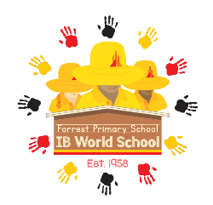

Forrest Primary School

9 Hobart Avenue, Forrest ACT 2603

Phone: 02 6142 1470

Email: [forrestps@ed.act.edu.au](mailto:forrestps@ed.act.edu.au)

Website: [www.forrestps.act.edu.au](http://www.forrestps.act.edu.au)

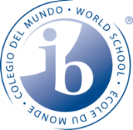

10 May 2022

**Year 5 Sexuality and Relationship Education (SRE) Session**

Dear Parent/ Carer,

On Tuesday 31 May the Year 5 students will engage in a **Sexuality and Relationships Education & Health** session. Students will be separated into male and female groups. The content covered will be the same. The **Sexuality and Relationships Education & Health** session will cover the following topics:

* Developmental changes for both boys and girls
* Development changes for boys only
* Developmental changes for girls only
* Physical and emotional aspects of human development
* Protective behaviours
* Relationships

Sexuality, health and relationships education is part of the Australian National Curriculum. It involves learning about physical growth and development, self-esteem, the body and relationships, a positive attitude towards sexuality, information to care for their bodies now and in the future and the development of skills to make healthy decisions. Parents and carers are the primary sexuality educators of their children. Our school supports parents and carers to provide sexuality and relationships education to their children.

|  |
| --- |
| **Date:** Tuesday 31 May 2022  **Cost:** $20 per student for a half-day session  **Venue:**  Forrest Primary School  **Due Date: Please return the payment section by Tuesday 24 May 2022** |

*It is customary for the school to request a financial contribution towards meeting the cost of your child’s participation in this program. These contributions are voluntary. The school has made every effort to keep costs of this activity at a reasonable level. We have an equity fund which can be used to provide financial assistance for students where parents are unable to make the requested contribution. If however there is insufficient funding available to meet the cost of this program, regrettably we may not be able to proceed****.***

Thank you for your continued support,

Jemma O’Brien - on behalf of the Year 5 teaching team.

Executive Teacher

**YEAR 5 SEXUALITY AND RELATIONSHIP EDUCATION (SRE) SESSION**

**PAYMENT – please return to school by Tuesday 24 May 2022**

Cost: $20 for a half-day session held on Tuesday 31 May 2022.

Payment in full is required by **Tuesday 24 May 2022**.

Child’s Name: _________________________________________ Class:______________________

Full name of parent (please print): ____________________________________________________

Signature of parent: ____________________________________ Date: ______________________

**METHOD OF $20 PAYMENT**

**Cash or cheque**

**Quickweb - VIA** [**www.forrestps.act.edu.au**](http://www.forrestps.act.edu.au)

**(FEE CODE: SRE22)** Receipt Number: ________________________

**The preferred method of payment is via Quickweb.**

**All cheques must be made payable to Forrest Primary School.**

**Cash payments need to be CORRECT MONEY, as we do not have change in the front office.**